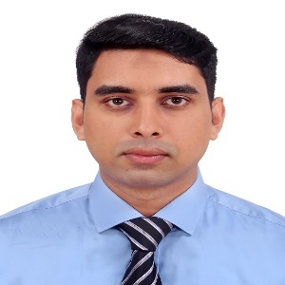
•Book Borrowing Management System
Platform : Web Technology:HTML,CSS,JavaScript,AJAX, MySQL,MVC
Link:https://github.com/imrancaptain/Project
•Metrorail-Station Management System
Platform:C# Technology:.Net
Link:https://github.com/imrancaptain/Project
/

EDUCATION
Sc. in Computer Science and Engineering
American International University-Bangladesh
Graduated: 2025
Higher Secondary Certificate(HSC)
Quality Education College
2017
Secondary School Certificate(SSC)
Dhakin Banasree.M.High School
2015
2

Graduated: 2025

Md.Imran Ahmed
EXPERIENCE
Customer Service Officer
WeTechHub(Dhaka) April08, 2026 – August,10 2026
- As a Customer Relationship Officer at WeTechHub, I manage and update customer data using CRM software to ensure accurate records and smooth communication.
- I handle inbound and outbound calls to assist clients, resolve queries, and maintain strong relationships.
- Additionally, I follow up with customers regarding services, provide support, and coordinate with internal teams to improve customer satisfaction.
Software Engineer
ICC Communication Ltd (Dhaka ) 1st November 2025 – May 30,2026
- Designing, developing,testing and maintaining software applications..
- Developing scalable,reliable and maintainable software solutions based on business requirements.
- Analyzing technical requirements and translating them into effective software solutions.
- Working with databases,including database design and maintenance.
- Performing application testing,debugging and performance optimization.
.
API design, Testing

SUMMARY
Software engineer with 2+ years of experience building scalable backend systems and responsive frontend applications. Passionate about automation, Soft design, and solving real-world problems through clean, efficient code. Known for mentoring junior developers, improving team workflows, and writing maintainable solutions. Seeking to contribute to innovative teams that value quality, collaboration, and impact.
API design, Testing

Projects

- HTML,CSS,PHP,Python, JS
- JavaScript,C#
- MySQL, MongoDB
- Docker, Git
- API design, Testing
- Management,Leadership,
Communication,Mentorship

CONTACT
Address :BaburJayga,Khilgaon,Dhaka-1219
Phone: 01626759580
Email:ahmedimraneng@gmail.com

Address: Babur Jayga,Khilgaon,Dhaka-1219

